

**Faculty: sir saad ahmed**

**Batch Coordinator: miss maha haider**

**batch code: 1808b1**

**GIFTS online**

**E-project user guide**

# **gifts online**

# **Project Group Members**

1. **Muhammad Hammad**

**Student1132559**

**mhammad523@gmail.com**

1. **Arbain Ansari**

**Student1132342**

**arbain.ansari3@gmail.com**

1. **Anas Nisar**

**Student1131100**

**anasnisar78690@gmail.com**

1. **Daniyal Hussain**

**Student1131666**

**hussaindaniyal29@gmail.com**

# **Acknowledgement**

**This eProject has been acknowlegded by:**

* **Muhammad Hammad**
* **Arbain Ansari**
* **Anas Nisar**
* **Daniyal Hussain**

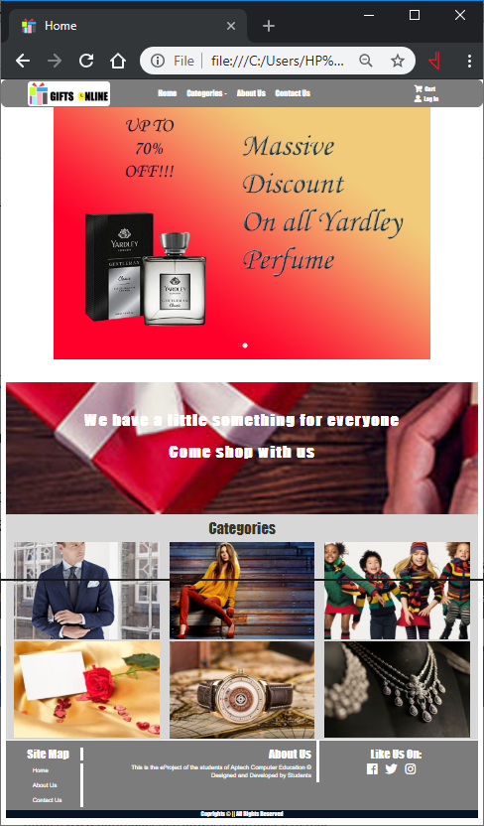**Index**

* **Home Page**
* **About Us Page**
* **Category Pages**
  + - * **Men**
      * **Women**
      * **Children**
      * **Watches**
      * **Jewelry**
      * **Cards**
* **Brand Pages**
  + **Adidas**
  + **Giorgio Armani**
  + **Gucci**
  + **Hallmark**
  + **Nike**
  + **Puma**
  + **RayBan**
  + **Reebok**
* **Comparisons Page**
* **Contact Us Page**

**Home Page Sample Guide**

This is our main page of website “Gifts Online”. It has our logo on the top-left, then our navigation bar that has:

* **Home Page**
* **Categories with dropdown menu**
* **About Us**
* **Contact Us**
* **Cart**
* **Log in**

Then we have given a slider for the users to know about our latest gift offers in short.

After that is a fixed image background which takes the user to an unfiltered gifts list.

Then we have added each category’s separate panels in which there are an abundance of products to choose from. Which are categorized below.

* **For Men**
* **For Women**
* **For Children**
* **Watches**
* **Jewelry**
* **Cards**

Then, after these panels we added the footer, that has our social & website’s page links.

**Product Page Sample Guide**

The Products page of website “Gifts Online”. It has our logo on the top-left, then our navigation bar that has:

* **Home Page**
* **Categories with dropdown menu**
* **About Us**
* **Contact Us**
* **Cart**
* **Log in**

After that on the right is are the links for brand products, categorised by:

* **Adidas**
* **Giorgio Armani**
* **Gucci**
* **Hallmark**
* **Nike**
* **Puma**
* **RayBan**
* **Reebok**

The rest of the page are the products of the category.